79.
a) $y = -2x + 3$
$$a = -2$$
$$b=3$$

b) $y = x$
$$a = 1$$
$$b=0$$

c) $y = 5$
$$a = 0$$
$$b=5$$

d)
$$y = -\frac{1}{3}x + 0.2$$
$a = -\frac{1}{3}$
$$b=0.2$$

e)
$y = -\frac{2}{3}x + 3$
$a = -\frac{2}{3}$
$b=3$

f)
$$y = x + 12$$
$$a = 1$$
$$b=12$$
g)
$y =\frac{1}{4}x +\frac{1}{20}$
$a =\frac{1}{4}$
$b=\frac{1}{20}$

h)
$$y = -\frac{8}{9}x +\frac{1}{4}$$
$a = -\frac{8}{9}$
$b=\frac{1}{4}$

80.
a)
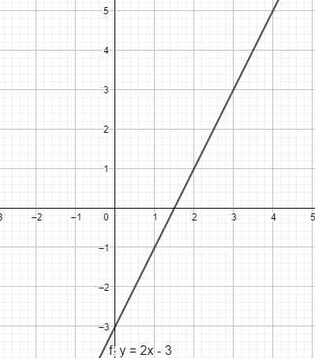
b)
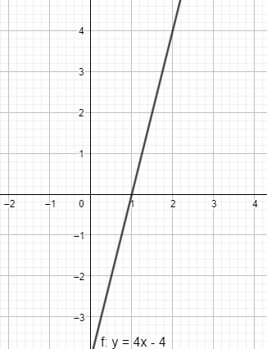
c)
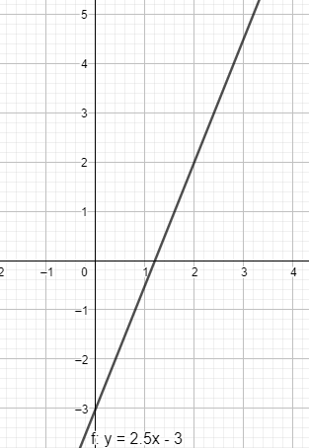

d)
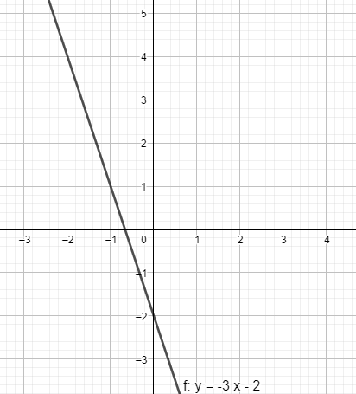
81.
a) y = 2x-2
b) y = -5x
c) $y=-\frac{2}{3}x+1$
d) y=4

82.
a) y – os (0,2)
0=x-2
x=2
x – os (2,0)

b) y – os (0,4)
0=-2x+4
2x=4
x=2
x – os (2,0)

c) y – os (0,0.25)
0=-x+0.25
x=0.25
x – os (0.25,0)

d) y – os (0,2)
$$0=\frac{1}{2}x+2$$
$\frac{1}{2}x=-2$
x=-4
x – os (-4,0)

83.
a) y = 2, y = -3
b) x = 2, x = - 3

84.
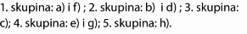
85.
a) $a=-\frac{3}{4}$
b) b=2
c)
$$0=-\frac{3}{4}x+2$$
$\frac{3}{4}x=2$
$x=\frac{8}{3}$ $(\frac{8}{3},0)$

d) (0,2)
e) $-5=-\frac{3}{4}∙4+2$
$-5=-3+2$
$-5=-1$
Ne pripada.

f) $5=-\frac{3}{4}∙(-4)+2$
$5=3+2$
$5=5$
Pripada.

86.
a) y = -3
$$y=\frac{1}{2}x+3$$
$-3=\frac{1}{2}x+3$
$\frac{1}{2}x=-6$
$x=-12$

b) $y=1.75x-2$
$-3=1.75x-2$
$1.75x=-1$
$x=-\frac{4}{7}$

c) $y=-3x-\frac{3}{2}$
$-3=-3x-\frac{3}{2}$
$3x=\frac{3}{2}$
$x=\frac{1}{2}$

d) $y=-20x+17$
$-3=-20x+17$
$-20x=-20$
$x=1$

87.a) $y=-3.7x+b$
$5.2=-3.7∙2+b$
$b=5.2+7.4=12.6$
$y=-3.7x+12.6$

b) $y=\frac{2}{3}x+b$
$0=\frac{2}{3}∙\frac{3}{2}+b$
$b=0-1=-1$
$y=\frac{2}{3}x-1$

c) $y=-\frac{1}{4}x+b$
$-4=-\frac{1}{4}∙(-16)+b$
$b=-4-4=-8$
$y=-\frac{1}{4}x-8$
88.
a) $y=ax-2$
$12=a∙4-2$
$4a=14$
$a=\frac{7}{2}$
$y=\frac{7}{2}x-2$

b) $y=ax+2$
$-1=a∙7+2$
$7a=-3$
$a=-\frac{3}{7}$
$y=-\frac{3}{7}x+2$

c) $y=ax-5$
$-3=a∙(-9)-5$
$9a=2$
$a=\frac{2}{9}$
$y=\frac{2}{9}x-5$

89.
a) (0,-18)
0=-2.4x-18
2.4x=-18 /:2.4
x =7.5
(7,5,0)

b) (0,0.2)
0=-0.3x+0.2
0.3x=0.2 /:0.3
x =$\frac{2}{3}$
($\frac{2}{3}$,0)

c) $\left(0,-\frac{1}{2}\right)$
$0=-\frac{4}{5}x-\frac{1}{2}$
$\frac{4}{5}x=-\frac{1}{2}$
$x=-\frac{5}{8}$
$\left(-\frac{5}{8},0\right)$

d) $15y=6x+12$ /:15
$y=\frac{2}{5}x+\frac{4}{5}$
$\left(0,\frac{4}{5}\right)$
$0=\frac{2}{5}x+\frac{4}{5}$
$-\frac{2}{5}x=\frac{4}{5}$
$x=-2$
(-2,0)

90.
a) y=ax+3
0=2a+3
-2a=3
a=-1.5
$y=-1.5x+3$

b) $y=ax-3$
$0=-2a-3$
$2a=-3$
$a=-1.5$
$y=-1.5x-3$

c) $y=ax+1$
$0=-4a+1$
$4a=1$
$a=0.25$
$y=0.25x+1$

d) $y=-2$

91.
a) (0,6.8)
0=-5.1x+6.8
5.1x=6.8
x=$\frac{4}{3}$
($\frac{4}{3},0)$

b) $P=\frac{\frac{4}{3}∙6.8}{2}=\frac{68}{15}$

92.
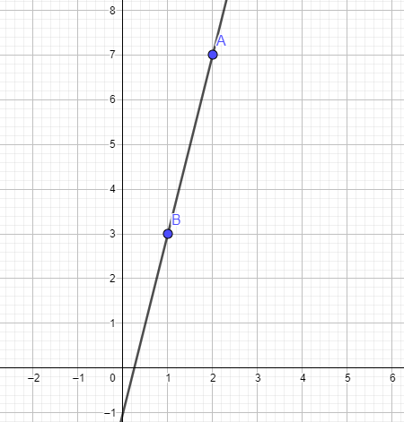
y =ax-1
3=a-1
a=4
y=4x-1
b) (0,-1)
0=4x-1
$4x=1$
$x=\frac{1}{4}$
$\left(\frac{1}{4}, 0\right)$

93.
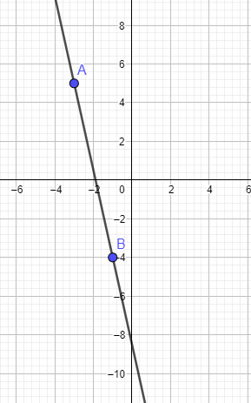
5=-3a+b
-4=-a+b /(-1)
5=-3a+b
4=a-b
9=-2a
a=$-\frac{9}{2}$
$-4=\frac{9}{2}+b$
$b=-\frac{17}{2}$
$y=-\frac{9}{2}x-\frac{17}{2}$

Priprema za ispit znanja
1.
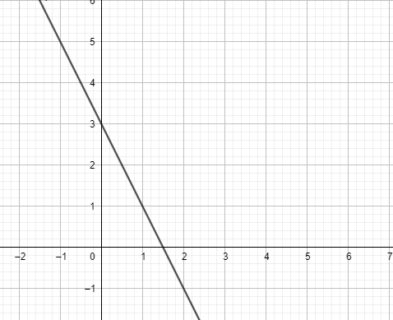
2.
y=2x-1
$3=2∙\left(-2\right)-1$
$3=-5$
A ne pripada.

$-5=2∙\left(-2\right)-1$
$-5=-5$
B pripada.

$3=2∙0-1$
$3=-1$
C ne pripada.
$-1=2∙1-1$
$-1=1$
D ne pripada.

3.
a) y = -4x + b
4=20 + b
b = -16
y = -4x – 16

b) y = ax+5
4=-5a+5
5a=1
$a=\frac{1}{5}$
$y=\frac{1}{5}x+5$

4.
a) $a=\frac{1}{2}$
b) (0,-1)
c) $0=\frac{1}{2}x-1$
$\frac{1}{2}x=1$
$x=2$
(2,0)

5.
a = -2
y=-2x+b
-5=-6+b
b=6-5=1

y=-2x+1

6.
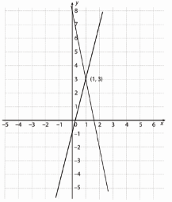
y=4x-1
y=-5x + 8 /(-1)
y=4x-1
-y=5x-8
0=9x-9
9x=9
x=1
y = 4-1 = 3
Rješenje je (1,3).

